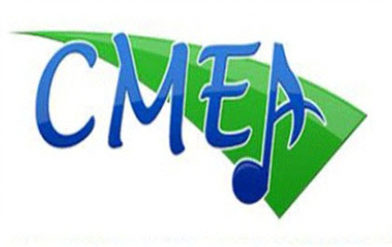
CMEA Orchestra Make-Over Festival
Registration Form
Friday February 23 and Saturday February 24, 2018
SOUTHERN BORDER SECTION
Wangenheim Middle School
Application Deadline: January 12, 2018

General Information
Please fill out a separate application for each Group

School Name _______________________________________________________________________________________________________

Name of Performing Group ______________________________________________________________________________________

Director Name _________________________________ Email __________________________________________

Phone: _________________________________________ CMEA ID#_____________________________________
CMEA Membership is required to participate in all CMEA Events

Schedule Preference
We will contact you individually to schedule a performance time upon receiving your application and participation fee. Friday sessions will run from approximately 2:30pm-5:30pm and Saturday sessions will run approximately from 9:00am-5:00pm.

Session preference: Friday _______PM Session
Saturday _______AM Session Saturday _______PM Session

Comments: ________________________________________________________________________________________________________________________

______________________________________________________________________________________________________________________________________

______________________________________________________________________________________________________________________________________

Festival Fee Schedule
Please make checks Payable to CMEA/SBS. Please enclose payments with the Registration Application---Spots cannot be held without complete payments.

Send Registration Fees Payable to CMEA/SBS to:

Attn: Cassandra Brown
Wangenheim Middle School
9230 Gold Coast Drive
San Diego, CA 92126

Important:
Entries not accompanied by a check or money order will not be scheduled

______ CMEA Member’s Fee Per Group: $200

Return your completed application and full payment no later than January 12, 2018.

